

SSO Implementation

User Manual
Govt. of Madhya Pradesh

Madhya Pradesh State Electronics Development Center (MPS@DC)
State IT Center, 47-A, Arera Hills, Bhopal, M.P. – 462011,
Phone: +91-755-2518300,
Fax: +91-755- 2579824
URL: www.mpsedc.mp.gov.in

Document Version History
Version | Date | Author | Comments
0.1 | 12-03-2025 | Dheeraj Motiyani | Initial Draft

Contents
1. Introduction 4
2. Purpose 4
3. Scope 4
4. Objective 5
5. Stakeholders 5
6. Process Flow 6
7. Functional Requirements 7
8. Non – Functional Requirements 11
9. Use Cases: 13
10. Tentative Mobile Screens 20
1. Login page 20
2. Dashboard – (Suggestion: Also add Project Work Order Document Feature) 21
3. Project List 22
4. Project Details 23
5. Installment 24
6. Installment Details 25
7. Offline Projects 26
11 Sign-Off 26

1. Register

Register on SSO Website: https://sso.mp.gov.in/ under Register link at bottom

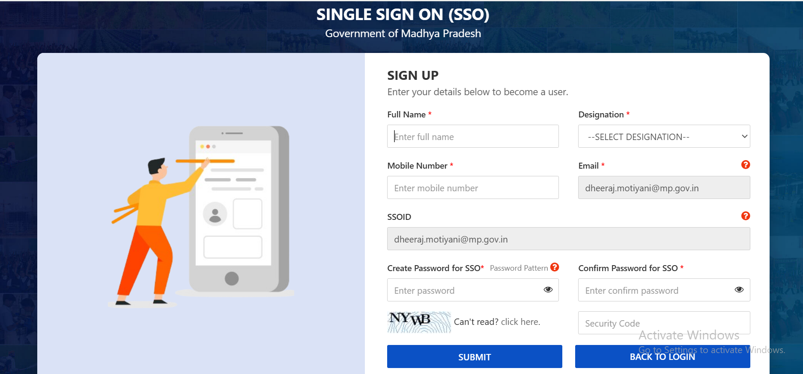

2. Login
Login to SSO Website : https://sso.mp.gov.in/
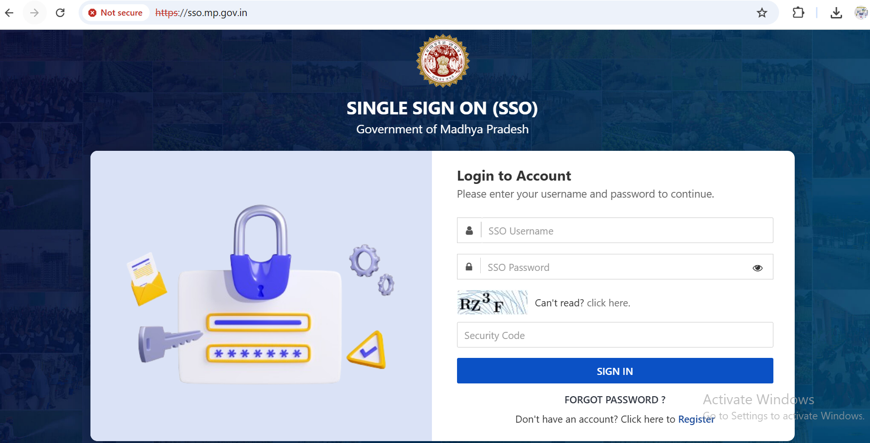

3. Verify by OTP
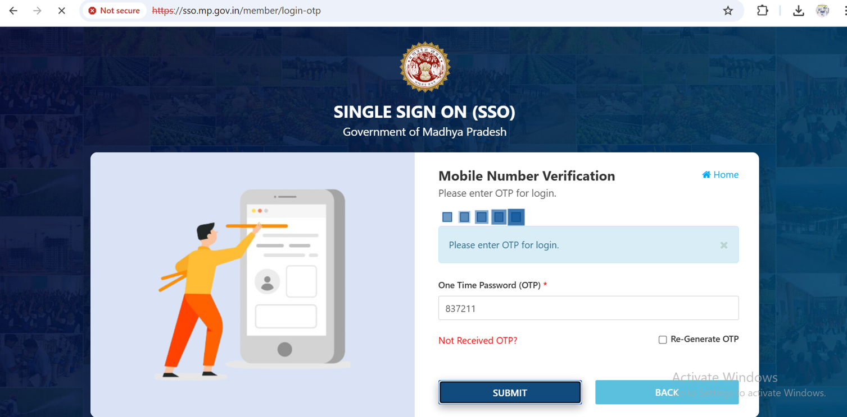

4. Go to the Dashboard
(Update Profile and below it verify Mobile Number by OTP)
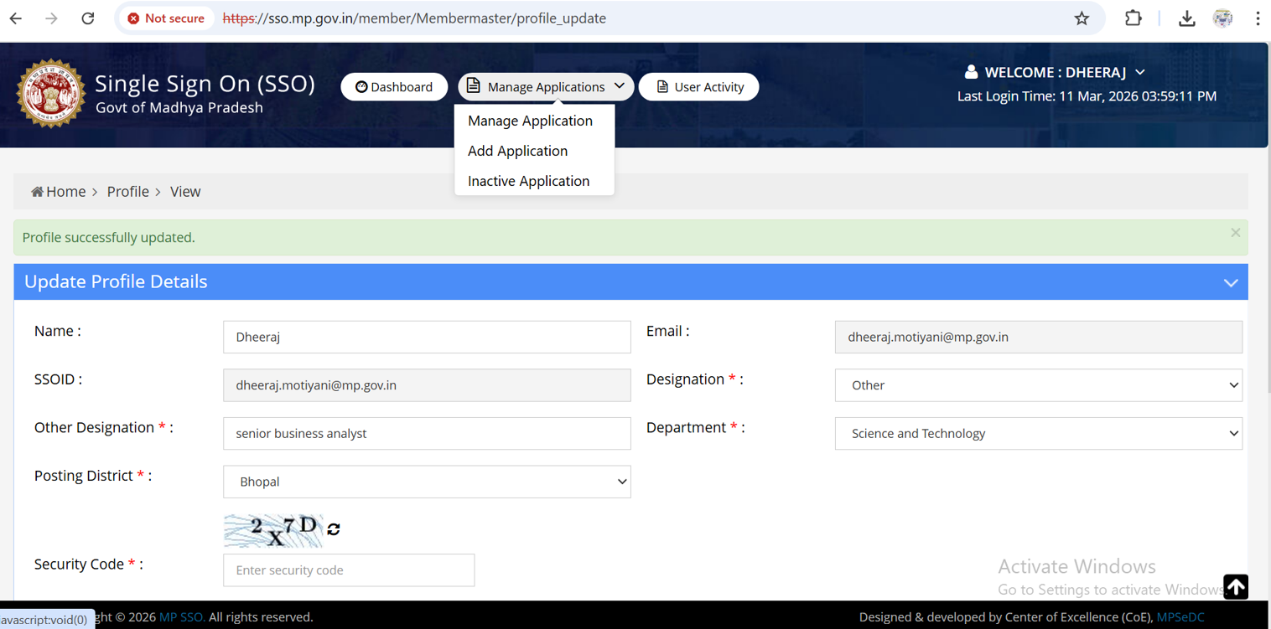

5. Manage Application Tab
Under it ADD Option – Add Application to be managed
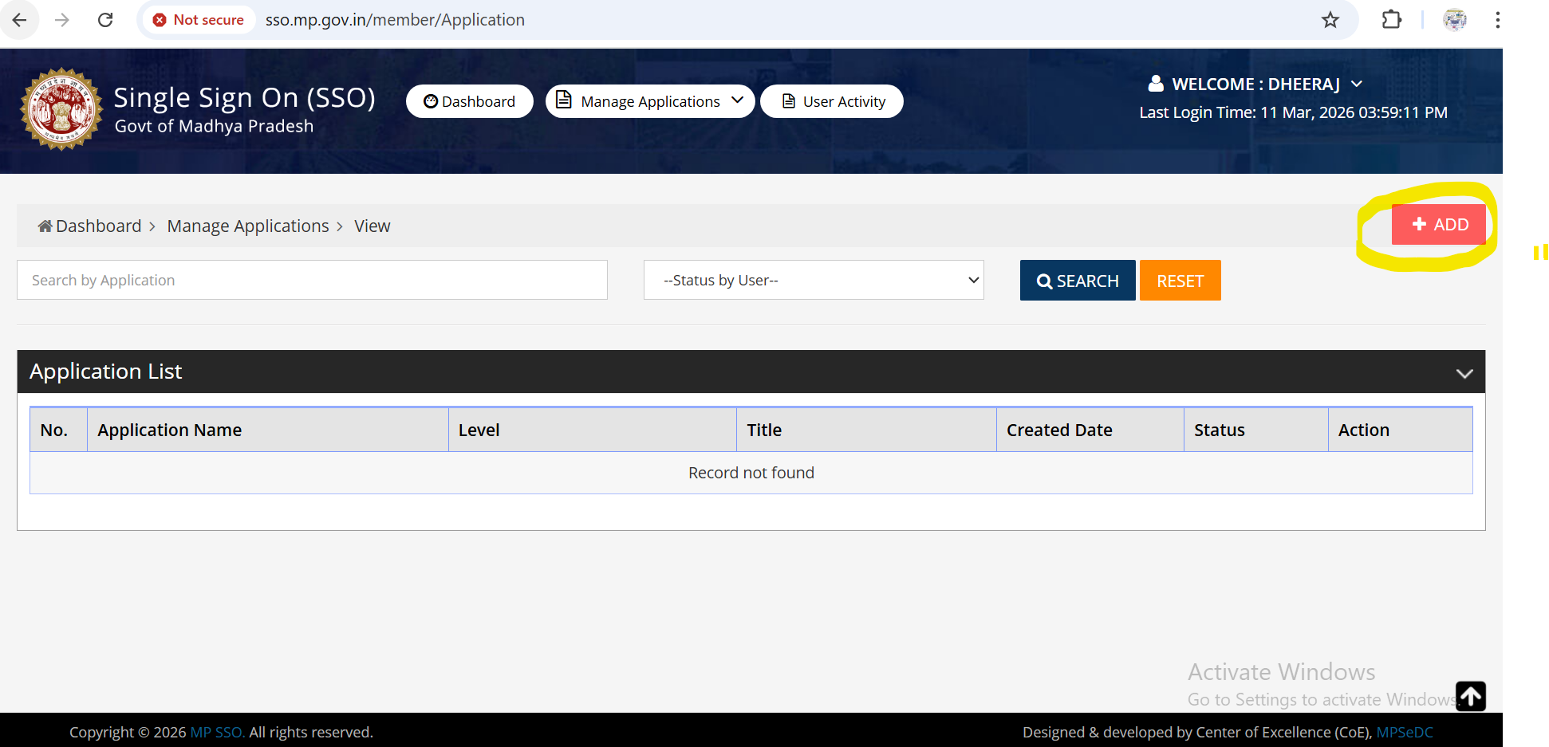
6. Select Respective Application
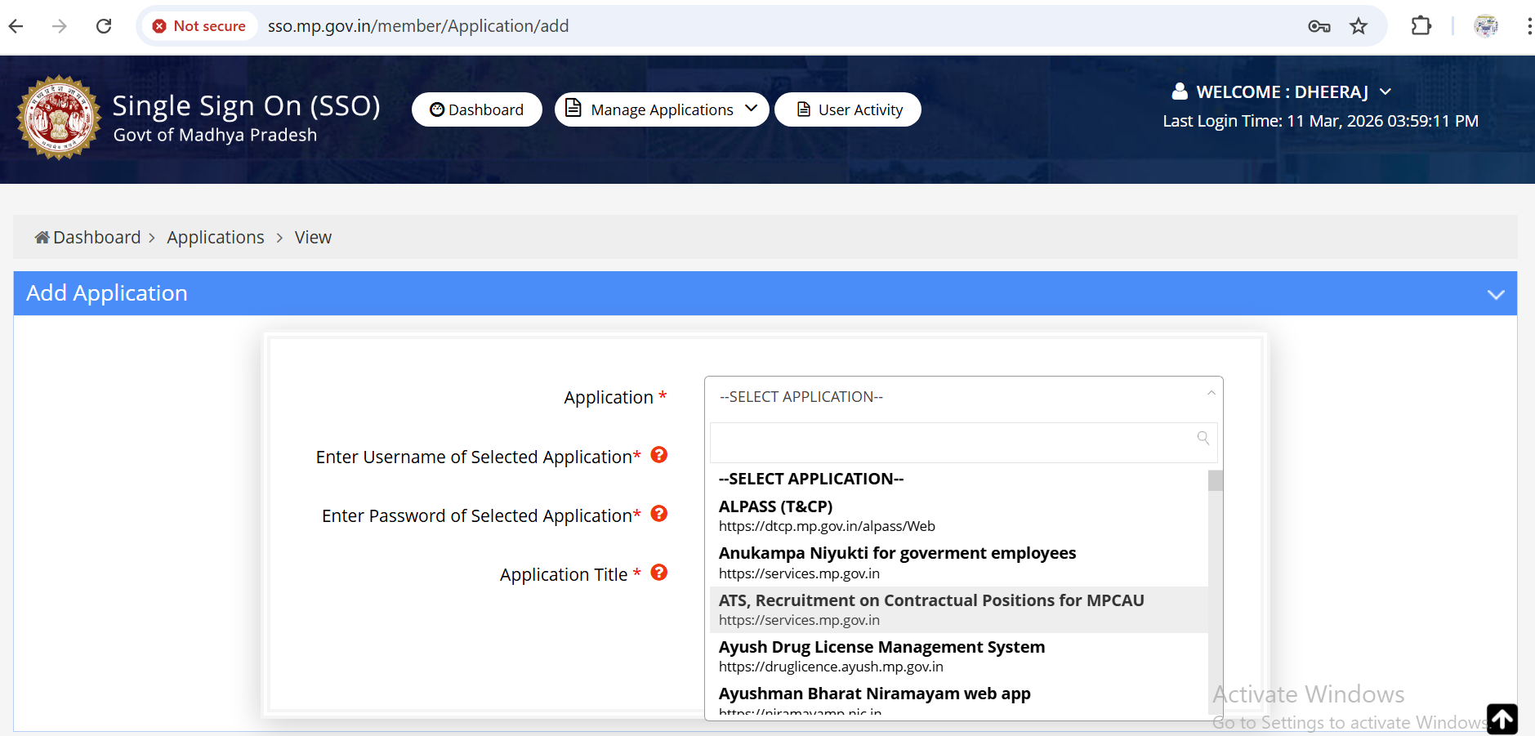

7. Authentication
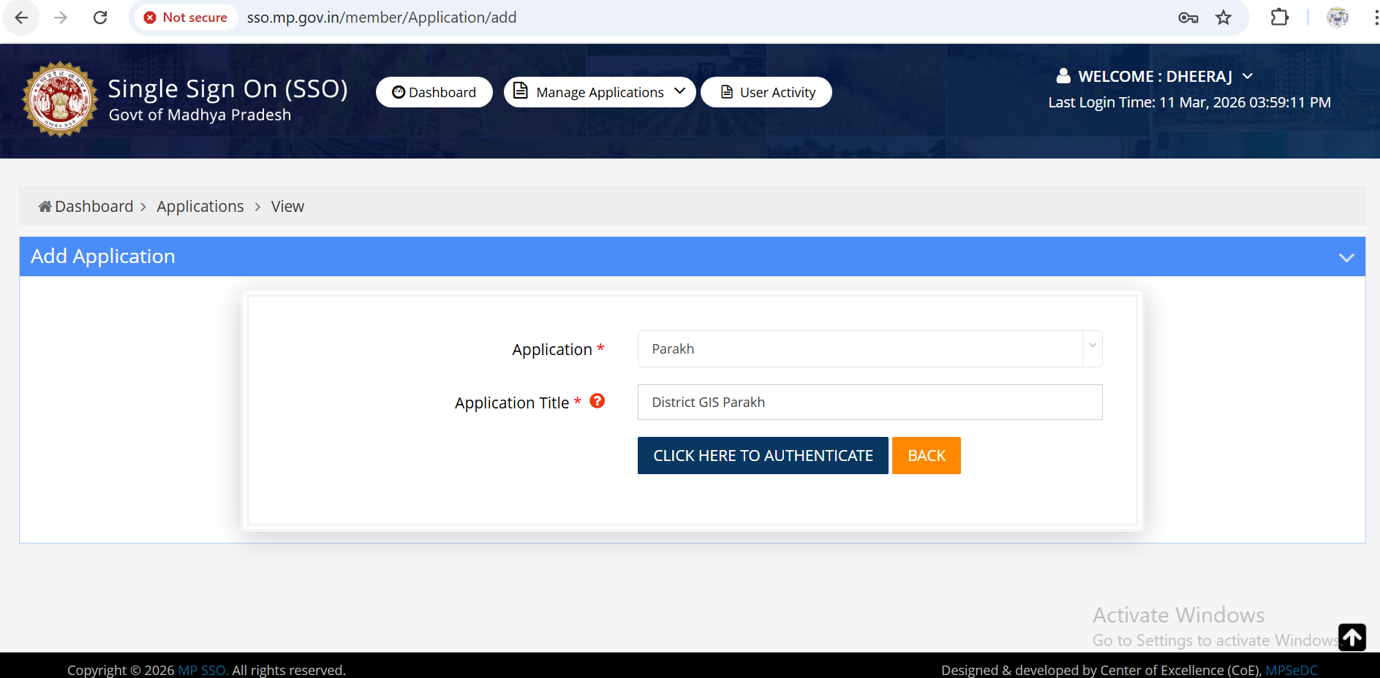

8. Application Added Successfully

Application added successfully into the Application list
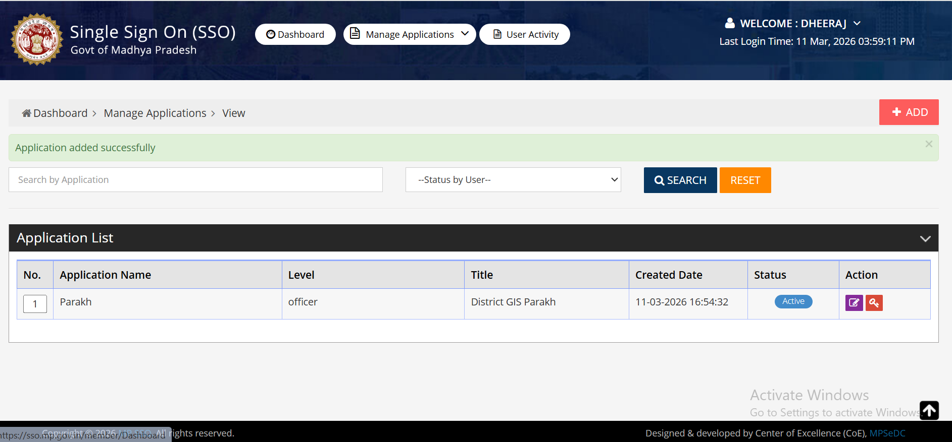

9. Dashboard
Now, Application will be visible on Dashboard and after clicking it you are directly redirected inside that application.

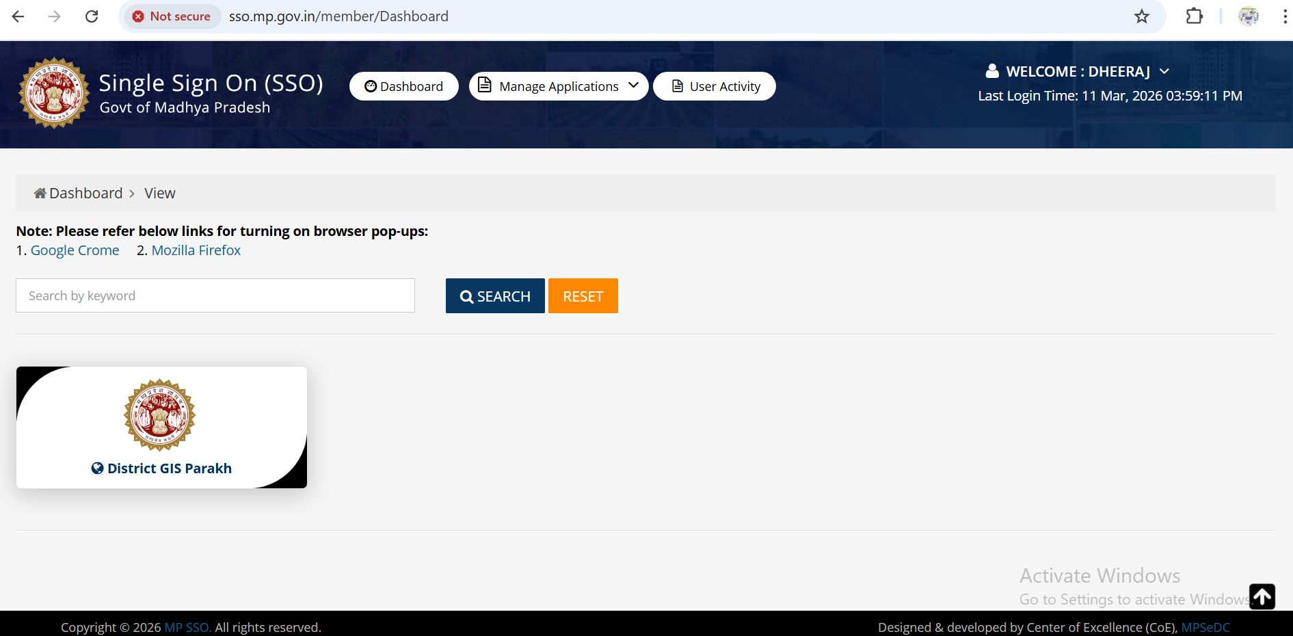

(Click on this District GIS Parakh Tile: You will be redirected towards that respective district home page inside the application.)

